Web Browser

**Web Browser** is an application software that allows us to view and explore information on the web. User can request for any web page by just entering a URL into address bar.

Web browser can show text, audio, video, animation and more. It is the responsibility of a web browser to interpret text and commands contained in the web page.

Earlier the web browsers were text-based while now a days graphical-based or voice-based web browsers are also available. Following are the most common web browser available today:

|  |  |
| --- | --- |
| **Browser** | **Vendor** |
| Internet Explorer | Microsoft |
| Google Chrome | Google |
| Mozilla Firefox | Mozilla |
| Netscape Navigator | Netscape Communications Corp. |
| Opera | Opera Software |
| Safari | Apple |
| Sea Monkey | Mozilla Foundation |
| K-meleon | K-meleon |

Architecture

There are a lot of web browser available in the market. All of them interpret and display information on the screen however their capabilities and structure varies depending upon implementation. But the most basic component that all web browser must exhibit are listed below:

* Controller/Dispatcher
* Interpreter
* Client Programs

**Controller** works as a control unit in CPU. It takes input from the keyboard or mouse, interpret it and make other services to work on the basis of input it receives.

**Interpreter** receives the information from the controller and execute the instruction line by line. Some interpreter are mandatory while some are optional For example, HTML interpreter program is mandatory and java interpreter is optional.

**Client Program** describes the specific protocol that will be used to access a particular service. Following are the client programs tat are commonly used:

* HTTP
* SMTP
* FTP
* NNTP
* POP

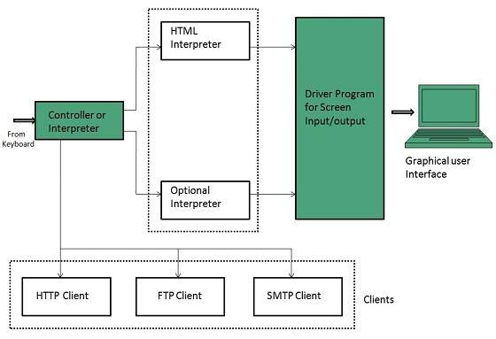

# Website Architecture

## What Does Website Architecture Mean?

Website architecture is the planning and design of the technical, functional and visual components of a website - before it is designed, developed and deployed. It is used by website designers and developers as a means to design and develop a website.

## Explains Website Architecture

Website architecture is used in creating a logical layout of a website in line with the user and/or business requirements. It defines the different components that will make up a website and the services each component or the website will provide in whole.

Some of the factors that are part of website architecture are:

* Technical constraints such as server, storage. memory and communication interfaces.
* Functional aspects such as the type of services or processes the website will provide.
* Visual appearance, i.e. the user interface, colors, buttons and other visual design elements.
* Security parameters i.e. how the website will ensure secure access control and transactions.

A definition of website architecture

Website architecture refers to the way we structure a website to ensure we meet our business goals while delivering a great experience for our users.

Where [information architecture](https://blog.optimalworkshop.com/learn-about-information-architecture/) (IA) is a broad field that refers to the structure of any shared system of information, online or otherwise, website architecture relates specifically to websites. All websites have an [IA](https://blog.optimalworkshop.com/learn-about-information-architecture/) but the overall picture of a website’s architecture also includes:

* usability
* interaction design
* user interface design
* information design
* web design
* graphic design
* content strategy

Creating a website architecture plan

Developing the architecture for a website is an essential part of the web design process and there’s a lot to be considered. Before you develop your structure, you need a plan to ensure your approach suits both business requirements and user needs.

1. **Frame your approach:** Are you redesigning an existing website or designing something new? If it’s an existing website, you will need time to gain a thorough understanding of the current state, so you can [benchmark your information architecture](https://blog.optimalworkshop.com/how-to-benchmark-your-information-architecture/), before moving on to anything else.
2. **Understand the business goals:** Whether you’re redesigning or designing something new, you will require a firm understanding of the intent, drivers, and goals of the business. Knowing this will enable you to make sound design decisions, keeping your project on track.
3. **Understand your user:** Engage with your users and conduct research to understand their needs, behaviors, and motivations. You may have completed some [user research](https://blog.optimalworkshop.com/19-user-research-tips-from-2019/) recently, so this is an opportunity to build upon and validate those findings. If you’re redesigning, you might consider running a usability test on the current state for benchmarking purposes.
4. **Create**[**personas**](https://www.smashingmagazine.com/2014/08/a-closer-look-at-personas-part-1/)**:** Once you’ve completed your user research, a great way to translate those findings into a usable format is through personas. A persona is a story about a fictional user that is based on information gathered from actual users. They have a name, a background story, and a photo that allows your team to put a human face to the people for which you are designing. Print them out and refer to them as you design your structure.
5. **Gather your content:** Before designing (or redesigning) a website architecture, assemble all your content and ensure it is current, accurate, and consistent. You can only decide upon a website architecture structure if you know what it is you’re structuring in the first place. If you attempt to do this before you have your content, you will most likely spend a lot of time updating and reworking it over the course of your project. Not only is this a waste of time and resources, but you run the risk of losing sight of the original purpose of the website, which can derail the entire project and result in even more work.
6. **Run a card sort:** Once you have collated the content for your website, it’s a good idea to [run a card sort](https://www.optimalworkshop.com/optimalsort/) with your users to determine how your content should be grouped. If you conduct the study as an [open card sort](https://www.optimalworkshop.com/learn/101s/card-sorting/), you can also gain insights into how your users might expect your content to be labelled. A [card sort](https://www.optimalworkshop.com/learn/101s/card-sorting/) can be run as a moderated study or you could use [OptimalSort](https://www.optimalworkshop.com/optimalsort/), which allows you to reach a larger audience and does most of the analysis work for you. OptimalSort also makes moderated card-sorting easier by providing the option to print out your cards, giving you the best of both worlds.